#### INTRODUCTION

* 1. *Overview*

This project helps you to maintain and manage the school related problems which further can be modified based on the requirements

* 1. *Purpose*

The goal is simple improve business relationship

1. ***ProblemDefinition& DesignThinking***
   1. *EmpathyMap*

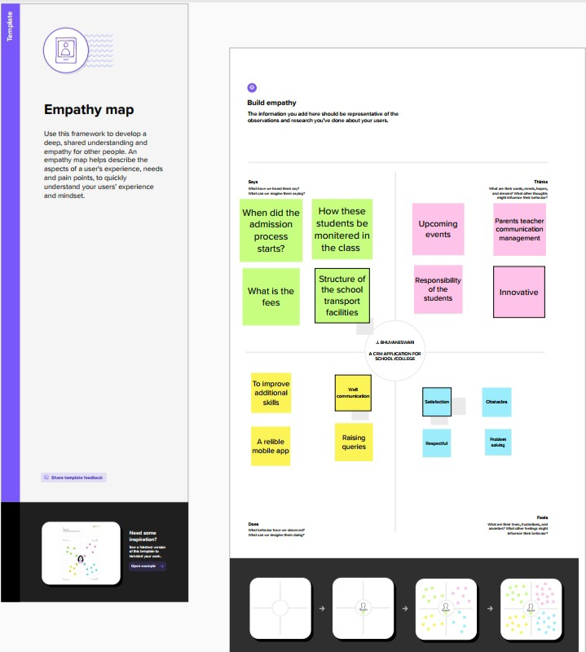

* 1. *Ideation&BrainstormingMap*

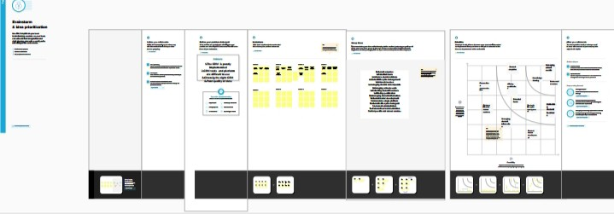

PastetheIdeation&brainstormingmapscreenshot

#### RESULT

* 1. *DataModel:*

|  |  |
| --- | --- |
| *Fieldlabel* | *Data type* |
| *Nama* | *Auto number* |
| *Results* | *Picklist* |

|  |  |
| --- | --- |
| ***Objectname*** | ***FieldsintheObject*** |
| *obj1 Student* |  |
| *obj2 Parent* |  |

* 1. ***Activity&Screenshot***

|  |  |
| --- | --- |
| *Fieldlabel* | *Data type* |
| *Parents Address* | *Text* |
| *Parents number* | *Phone* |

## Milestone:1

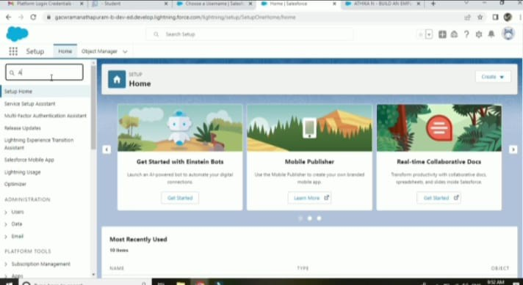We create developer org in Salesforce and give username and password to login. After login this is the homepage which you will see

## Milestone:2

*Activity-1 Creation of school object*

### Navigate to setup and select object manager and label name school and data type check box and save it



*ProjectReportTemplate*

# Milestone:3 Lighting app

*Create the school management app go to setup enter app manager click new lightning app enter school management as the app name click next*

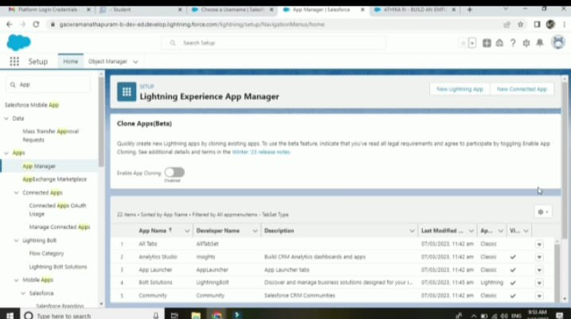

# Milestone:4

*Field and Relationship*

### Select the text area as the date type then click next. For field label enter address click the then save

*Select the master object summarized as students and select Marks as field to aggregate click next and save*

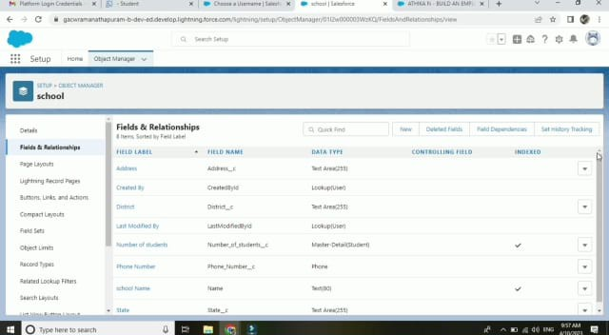

*Milestone:5 Creation of profile*

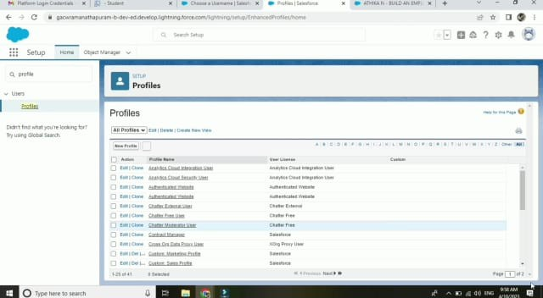*From setup entre profile in the quick find box,and select profile from the list of profile find standard user clicks clone for profile name enter school profile save it*

## Milestone:6 Users

*From setup in the quick find box enter users and then select users enter the users name parent and student email address and unique user name check generated new password and notify the users immediately to have the user log in*

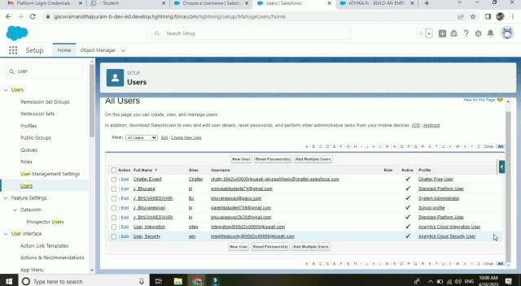

# Milestone:7

*Pemesion sets*

FROM set up enter permission set in the quick find box then select permission set s give the name of permission set name has teacher permission and then under the object sets give the view create and edit permission to all custome object and assign to the teacher user

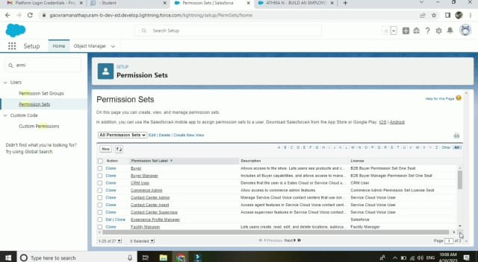

### Milestone:8 Reports

From the report tab click new report we select the report type has school with students and parents for the report and click create customised your report then save or run it

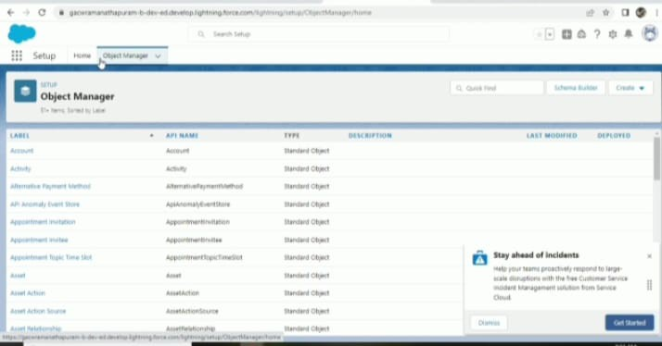

#### TrailheadProfilePublicURL Team Lead -

***https://trailblazer.me/id/bjeyapandi***

#### TeamMember1- https://trailblazer.me/id/afrin52 Team Member 2 - https://trailblazer.me

***/id/akalya2003***

#### TeamMember3–http s://trailblazer.me/id/ cmchandraleka

1. ***ADVANTAGES&DISADVANTAGE***

The advantages of a business using a CRM system greatly outweigh the disadvantages. However, there are pitfalls. For a CRM system to work, there needs to be buy-in across the organisation and the processes in place to support it. Otherwise, your CRM may end up being an expensive waste of time. Here, we take a look at the strategic pros, cons, and importance of CRM.

#### APPLICATIONS

Customer relationship management (CRM) is a technology for managing all your company's relationships and interactions with customers and potential customers.

#### CONCLUSION

CRM in retail allows businesses to make smarter decisions to better serve their customers and maximize profits from repeat purchases.

#### FUTURESCOPE

Customers will become a company's best sales reps through superior products and services as well as customer-oriented messaging. The future of CRM is more than just the future of Customer Relationship Management software. It is really the future of business.